Table of Contents

AZURE KUBERNETES SERVICES 2

KUBERNETES FEATURES 2

KUBERNETES ARCHITECTURE 2

# AZURE KUBERNETES SERVICES

* Kubernetes is an open-source orchestration software for deploying, managing, and scaling containers
* Kubernetes manage the containers that run out application and ensure there is no downtime
* It provides us a framework to run the distributed systems resiliently.
* Azure Kubernetes is the managed version of Kubernetes tool itself

## KUBERNETES FEATURES

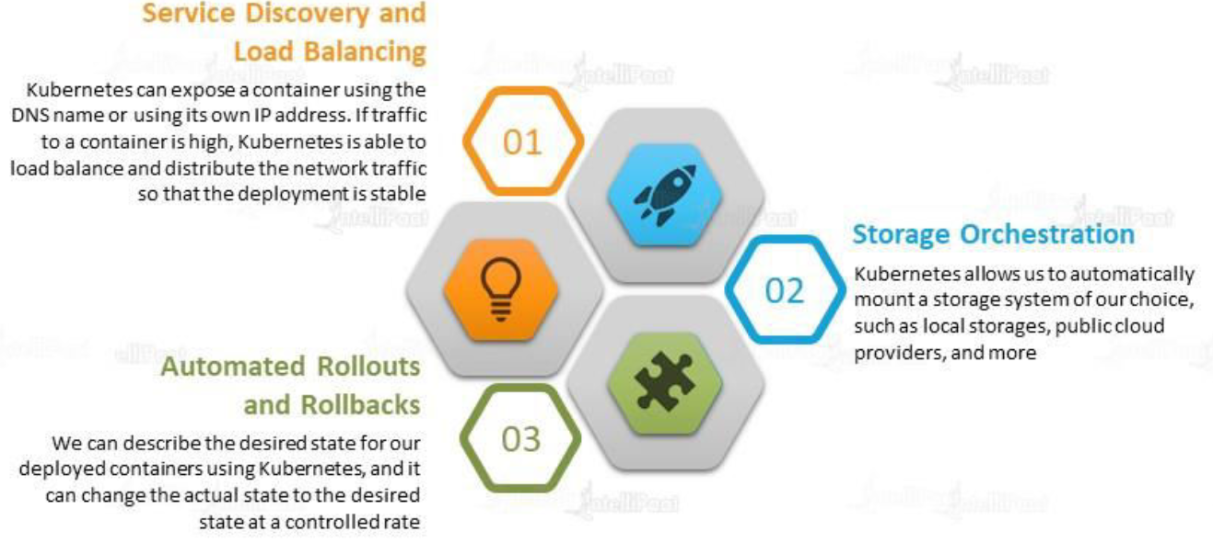

## KUBERNETES ARCHITECTURE

### NODES

|  |  |
| --- | --- |
|  | * A node is a machine – physical or virtual – on which Kubernetes is installed. * A node is a worker machine, and this is where containers will be launched by Kubernetes) It was also known as Minions in the past). * But what if the node on which our application is running fails? Well, obviously our application goes down. So, you need to have more than one node. Then comes the concept of Cluster |

### CLUSTER

|  |  |
| --- | --- |
|  | * A cluster is a set of nodes grouped together. * This way even if one node fails the application still accessible from the other nodes. * Having multiple nodes helps in sharing load as well. |

### MASTER

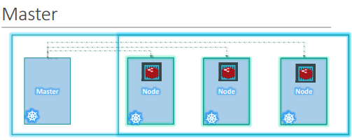

Master node is Kubernetes are

* Is responsible for managing the cluster
* Master has the information about the members of the cluster stored
* Monitoring the Nodes – For example - when a node fails it moves the workload of the failed node to another worker node

**The master is another node with Kubernetes installed in it and is configured as a Master. The master watches over the nodes in the cluster and is responsible for the actual orchestration of containers on the worker nodes.**

### COMPONENTS OF KUBERNETES

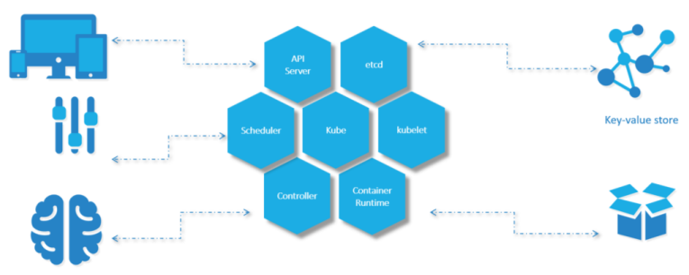

When we install Kubernetes on a System, following components get installed

1. AN API SERVER.

* The API server acts as the front-end for Kubernetes. **The users, management devices, Command line interfaces (kubectl)all talk to the API server to interact with the Kubernetes cluster.**

1. AN ETCD SERVICE.

* ETCD key store is a distributed reliable key-value store used by Kubernetes to store all data used to manage the cluster. For example - when we have multiple nodes and multiple masters in our cluster, etcd stores all that information on all the nodes in the cluster in a distributed manner.
* ETCD is responsible for implementing locks within the cluster to ensure there are no conflicts between the Masters.
* It stores the status information of the cluster

1. A KUBELET SERVICE.

* Kubelet is the agent that runs on each node in the cluster. The agent is responsible for making sure that the containers are running on the nodes as expected.
* To manage the node - Kubelet is an agent through with the nodes are managed

1. A CONTAINER RUNTIME

* The container runtime is the underlying software that is used to run containers. For example - Docker

1. CONTROLLERS

* The controllers are the brain behind orchestration. They are responsible for noticing and responding when nodes, containers or endpoints goes down. The controllers make decisions to bring up new containers in such cases.

1. SCHEDULERS.

* The scheduler is responsible for distributing work or containers across multiple nodes. It looks for newly created containers and assigns them to Nodes.
* For example – If we fire a “kubectl” command to create new containers – it will intercepted API server and then sent over to the scheduler to schedule the task of container creation.

### KUBERNETES IN AZURE

* Among the different components of Kubernetes – Some are Azure managed, and some are customer managed.
  + Azure Managed Kubernetes components are called “*Control Plane*”
  + Customer Managed Kubernetes components are called “Nodes”

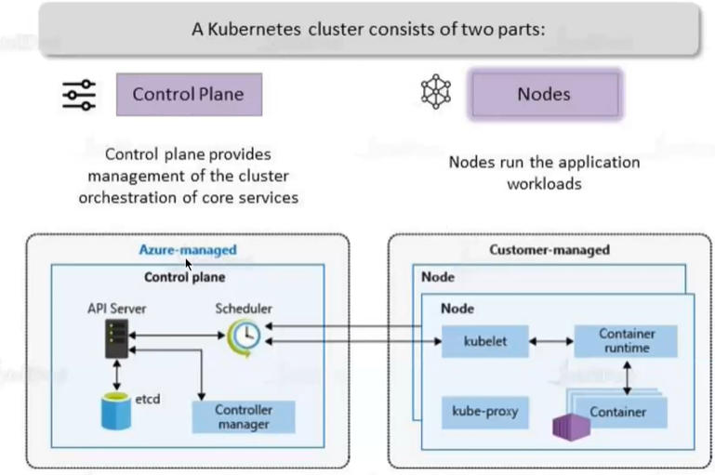

KUBE PROXY

* This allow us to configure networking like load balancing, traffic management etc..

|  |  |
| --- | --- |
|  | * The master / worker nodes are basically VM behind the scene. * All the VMs are managed by Azure itself |

### CREATING THE KUBERNETES SERVICE

* Search for Kubernetes service in the Azure Portals 🡪 Create

|  |  |
| --- | --- |
| NODE SIZE | Size in Underlying VM |
| NODE COUNT RANGE | Minimum and Maximum number of nodes |
|  |  |

* To deploy a container in Kubernetes cluster we can use YAML file
* The soucre of the image can be the ACR or Docker Hub

